Zomato clone with full ci-cd

Tools used in this project

• Jenkins

• Docker

• Docker Hub

• Git

• GitHub

• Argo CD

• Amazon Web Services (AWS)

• Amazon EC2

• Amazon EKS

• AWS IAM

• Kubernetes (k8s)

• SonarQube

• OWASP Dependency-Check

• Trivy

• Docker Scout

• Prometheus

• Grafana

• Node Exporter

• Node.js

• NPM

• Java (JDK)

• Visual Studio Code

pipeline {

agent any

tools {

jdk 'jdk17'

nodejs 'node23'

}

environment {

SCANNER_HOME=tool 'sonar-scanner'

}

stages {

stage ("clean workspace") {

steps {

cleanWs()

}

}

stage ("Git Checkout") {

steps {

git 'https://github.com/Piyush1patil/DevOps-Project-Zomato.git'

}

}

stage("Sonarqube Analysis"){

steps{

withSonarQubeEnv('sonar-server') {

sh ''' $SCANNER_HOME/bin/sonar-scanner -Dsonar.projectName=zomato \

-Dsonar.projectKey=zomato '''

}

}

}

stage("Code Quality Gate"){

steps {

script {

waitForQualityGate abortPipeline: false, credentialsId: 'Sonar-token'

}

}

}

stage("Install NPM Dependencies") {

steps {

sh "npm install"

}

}

stage('OWASP FS SCAN') {

steps {

dependencyCheck additionalArguments: '--scan ./ --disableYarnAudit --disableNodeAudit -n', odcInstallation: 'DP-Check'

dependencyCheckPublisher pattern: '**/dependency-check-report.xml'

}

}

stage ("Trivy File Scan") {

steps {

sh "trivy fs . > trivy.txt"

}

}

stage ("Build Docker Image") {

steps {

sh "docker build -t zomato ."

}

}

stage ("Tag & Push to DockerHub") {

steps {

script {

withDockerRegistry(credentialsId: 'docker') {

sh "docker tag zomato zomato453/zomato:latest"

sh "docker push zomato453/zomato:latest"

}

}

}

}

stage('Docker Scout Image') {

steps {

script{

withDockerRegistry(credentialsId: 'docker', toolName: 'docker'){

sh 'docker-scout quickview zomato453/zomato:latest'

sh 'docker-scout cves zomato453/zomato:latest'

sh 'docker-scout recommendations zomato453/zomato:latest'

}

}

}

}

stage ("Deploy to Container") {

steps {

sh 'docker run -d --name zomato -p 3000:3000 zomato453/zomato:latest'

}

}

}

post {

always {

emailext attachLog: true,

subject: "'${currentBuild.result}'",

body: """

<html>

<body>

<div style="background-color: #FFA07A; padding: 10px; margin-bottom: 10px;">

<p style="color: white; font-weight: bold;">Project: ${env.JOB_NAME}</p>

</div>

<div style="background-color: #90EE90; padding: 10px; margin-bottom: 10px;">

<p style="color: white; font-weight: bold;">Build Number: ${env.BUILD_NUMBER}</p>

</div>

<div style="background-color: #87CEEB; padding: 10px; margin-bottom: 10px;">

<p style="color: white; font-weight: bold;">URL: ${env.BUILD_URL}</p>

</div>

</body>

</html>

""",

to: ‘piyushpatil1451asada@gmail.com',

mimeType: 'text/html',

attachmentsPattern: 'trivy.txt'

}

}

}

# jenkins pipeline

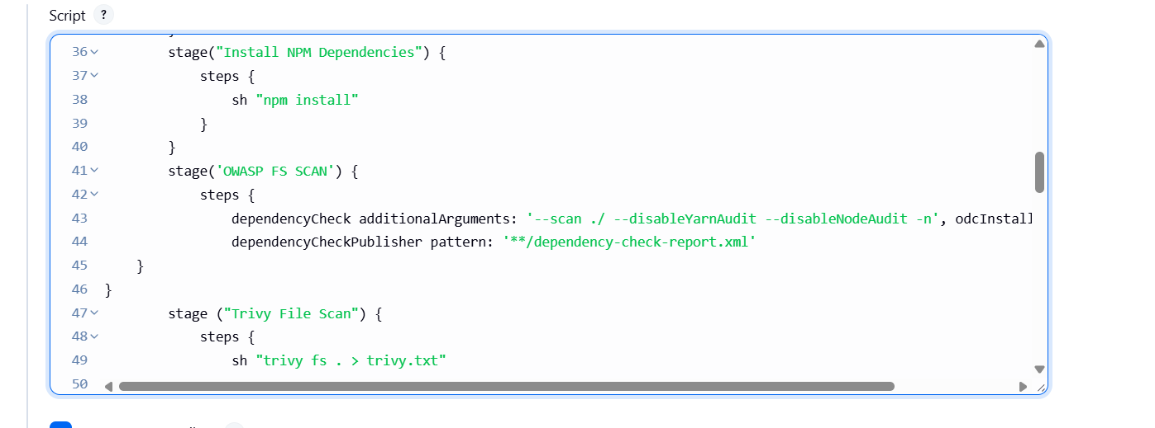

# Plugin need to install for smooth flow of pipeline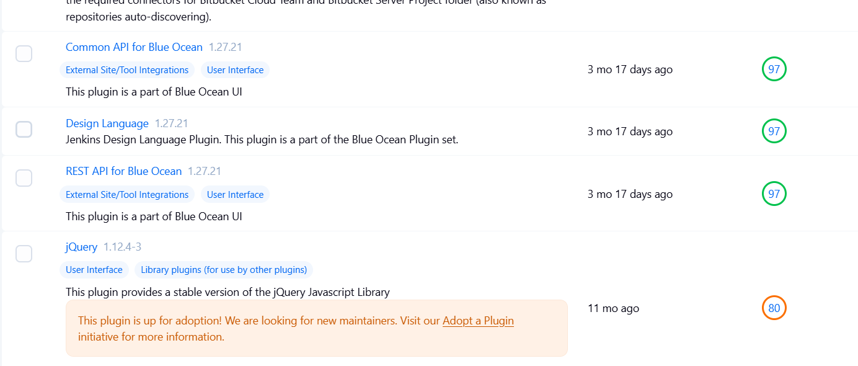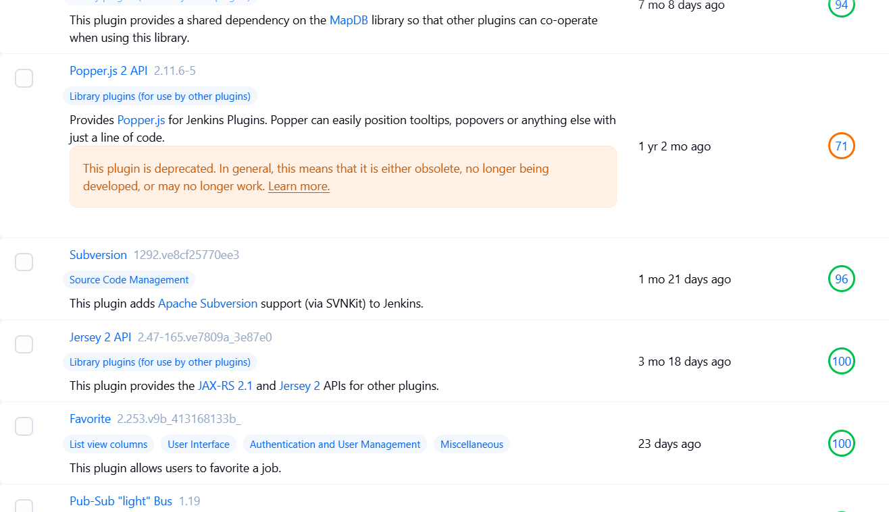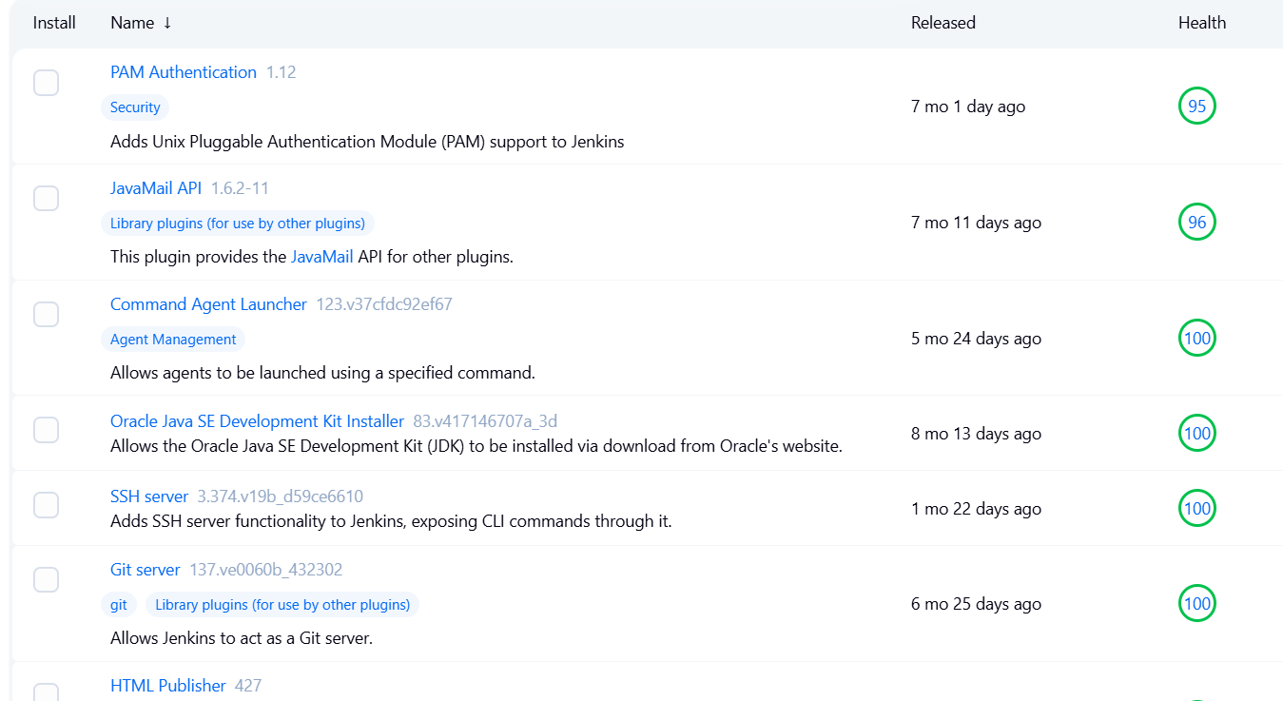

# sonarqube 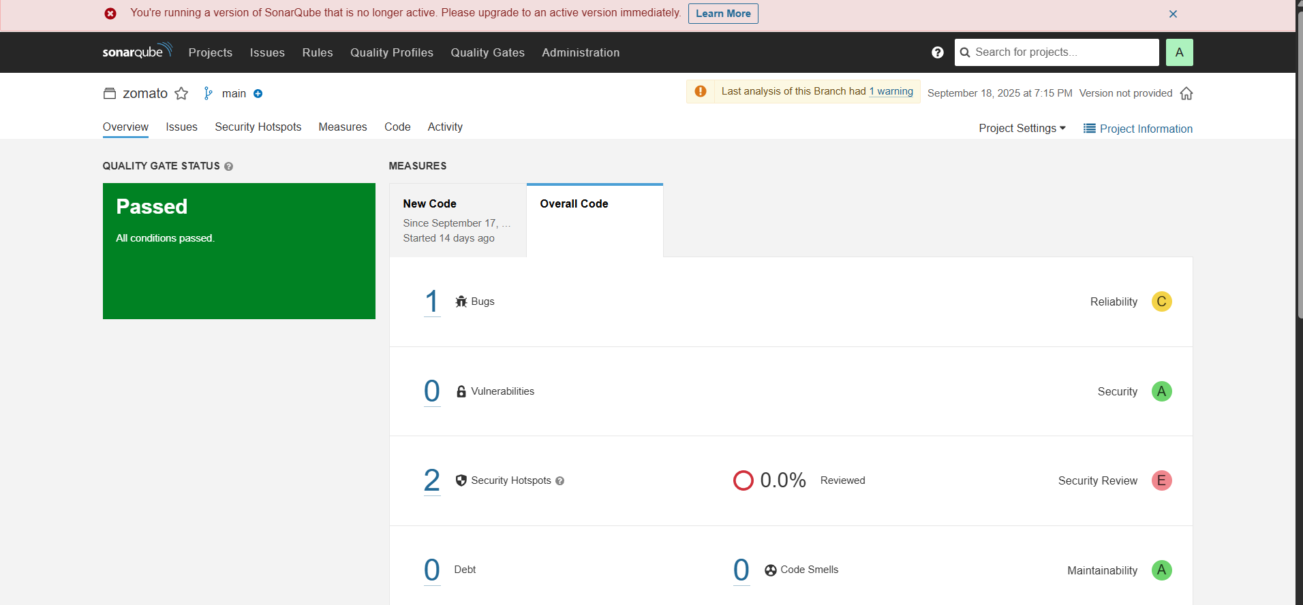

# Zoamto website hosted on docker container using Jenkins pipeline

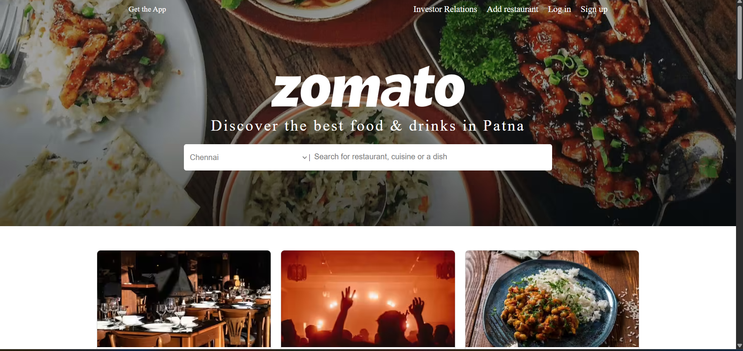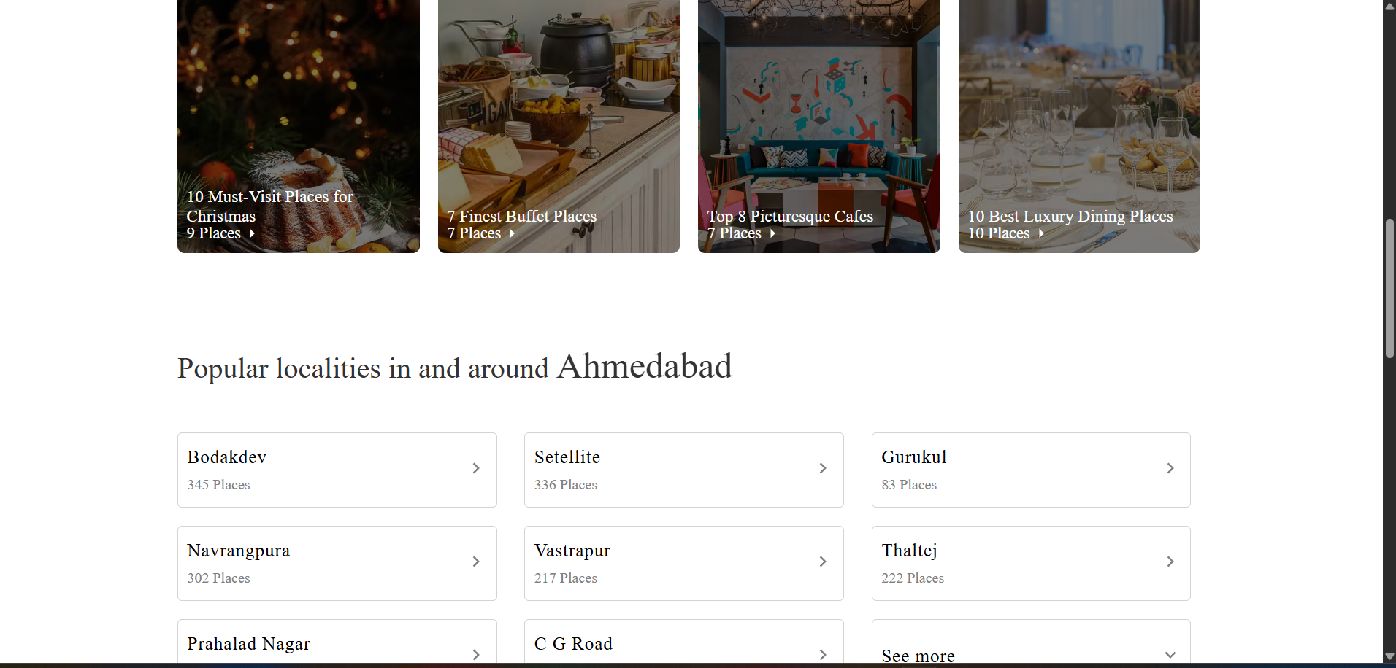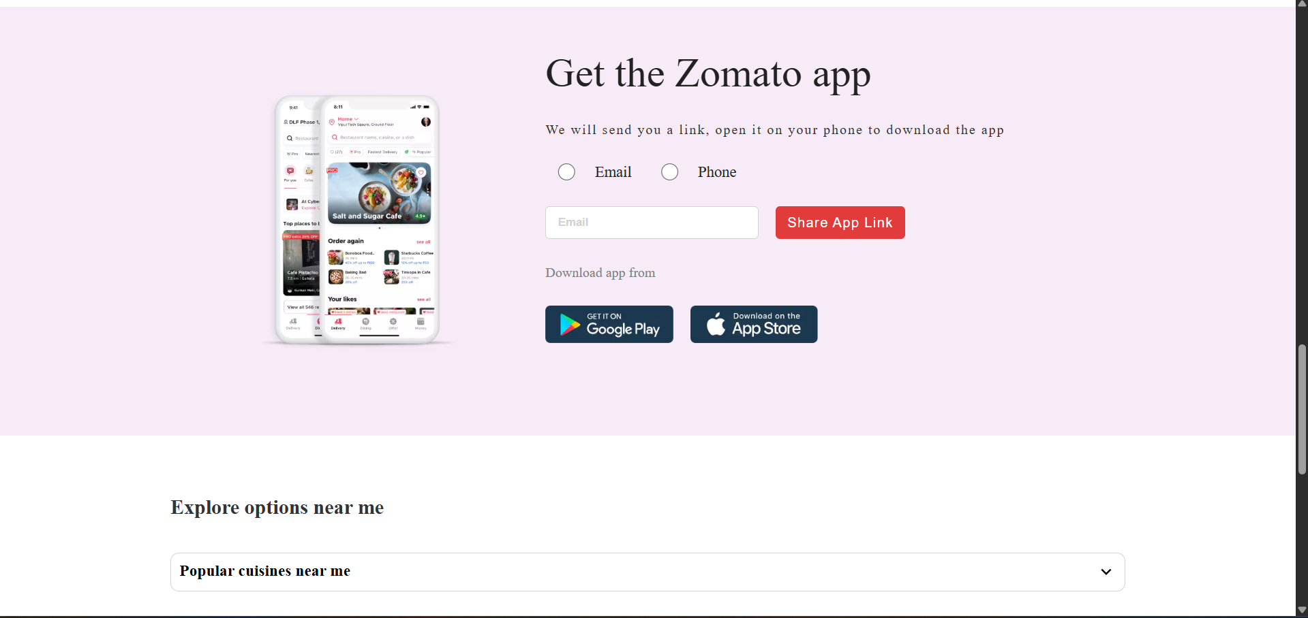

# instances hosting on AWS for Zomato- clone project

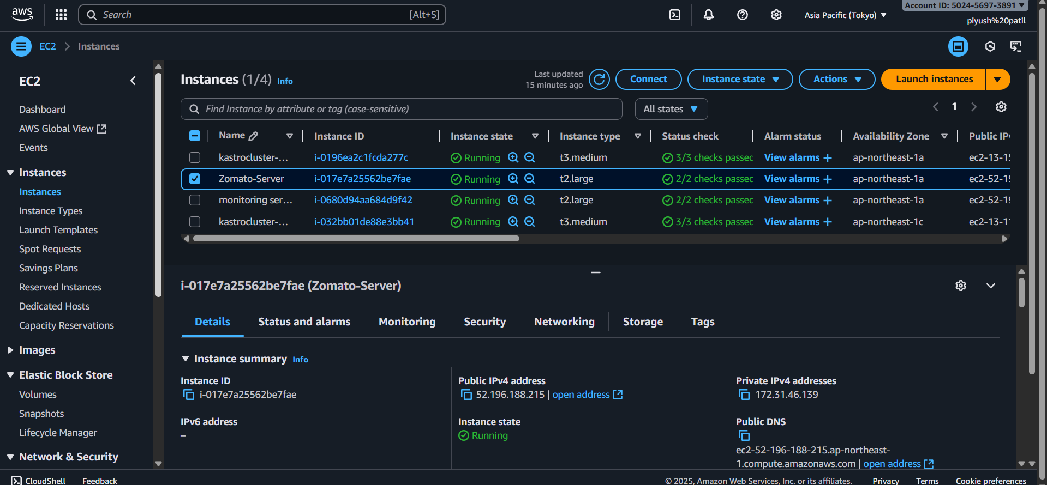

# Jenkins add url in jenkins

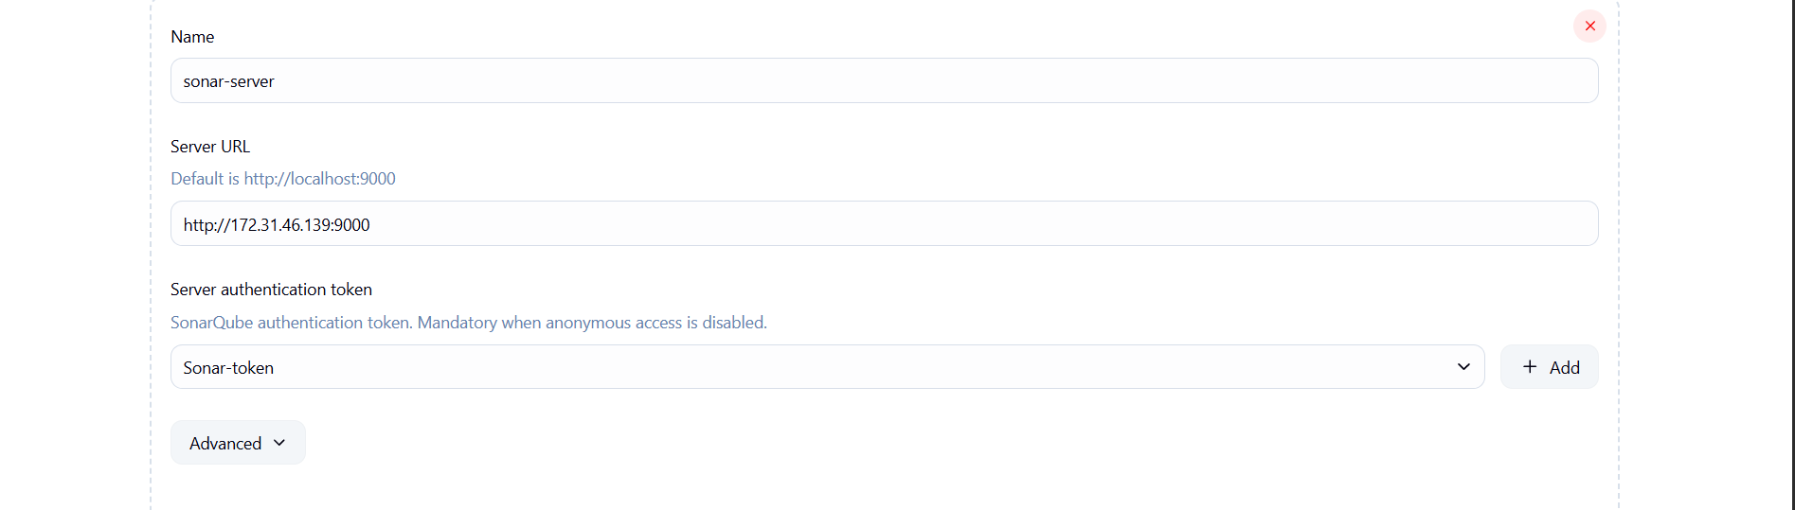

# add credentials in Jenkins

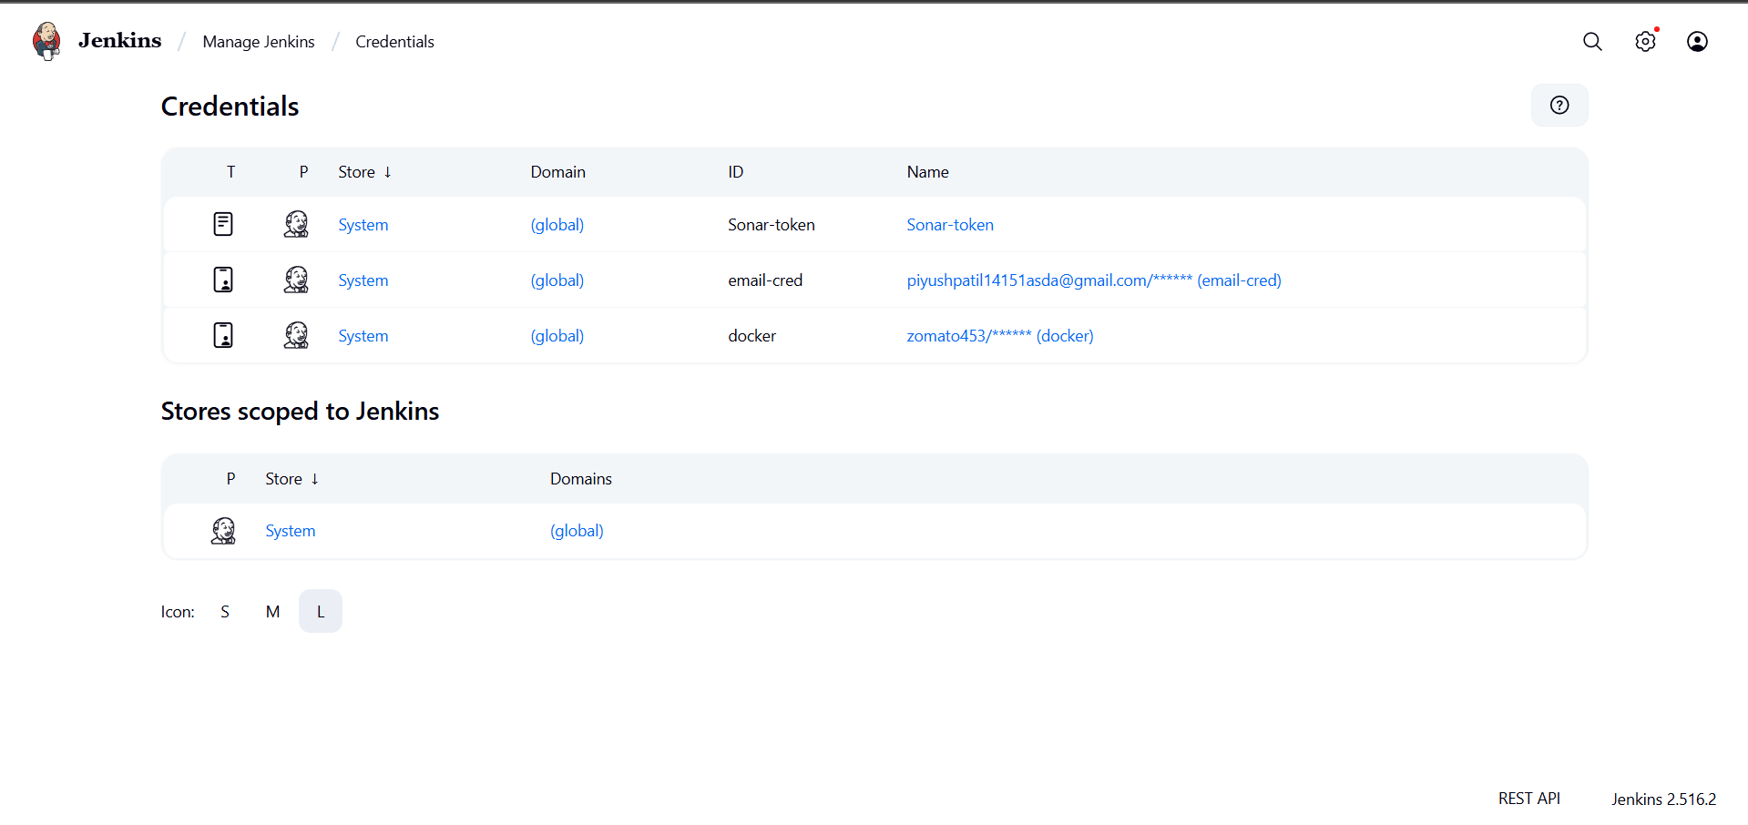

# sonarqube add Jenkins webhooks

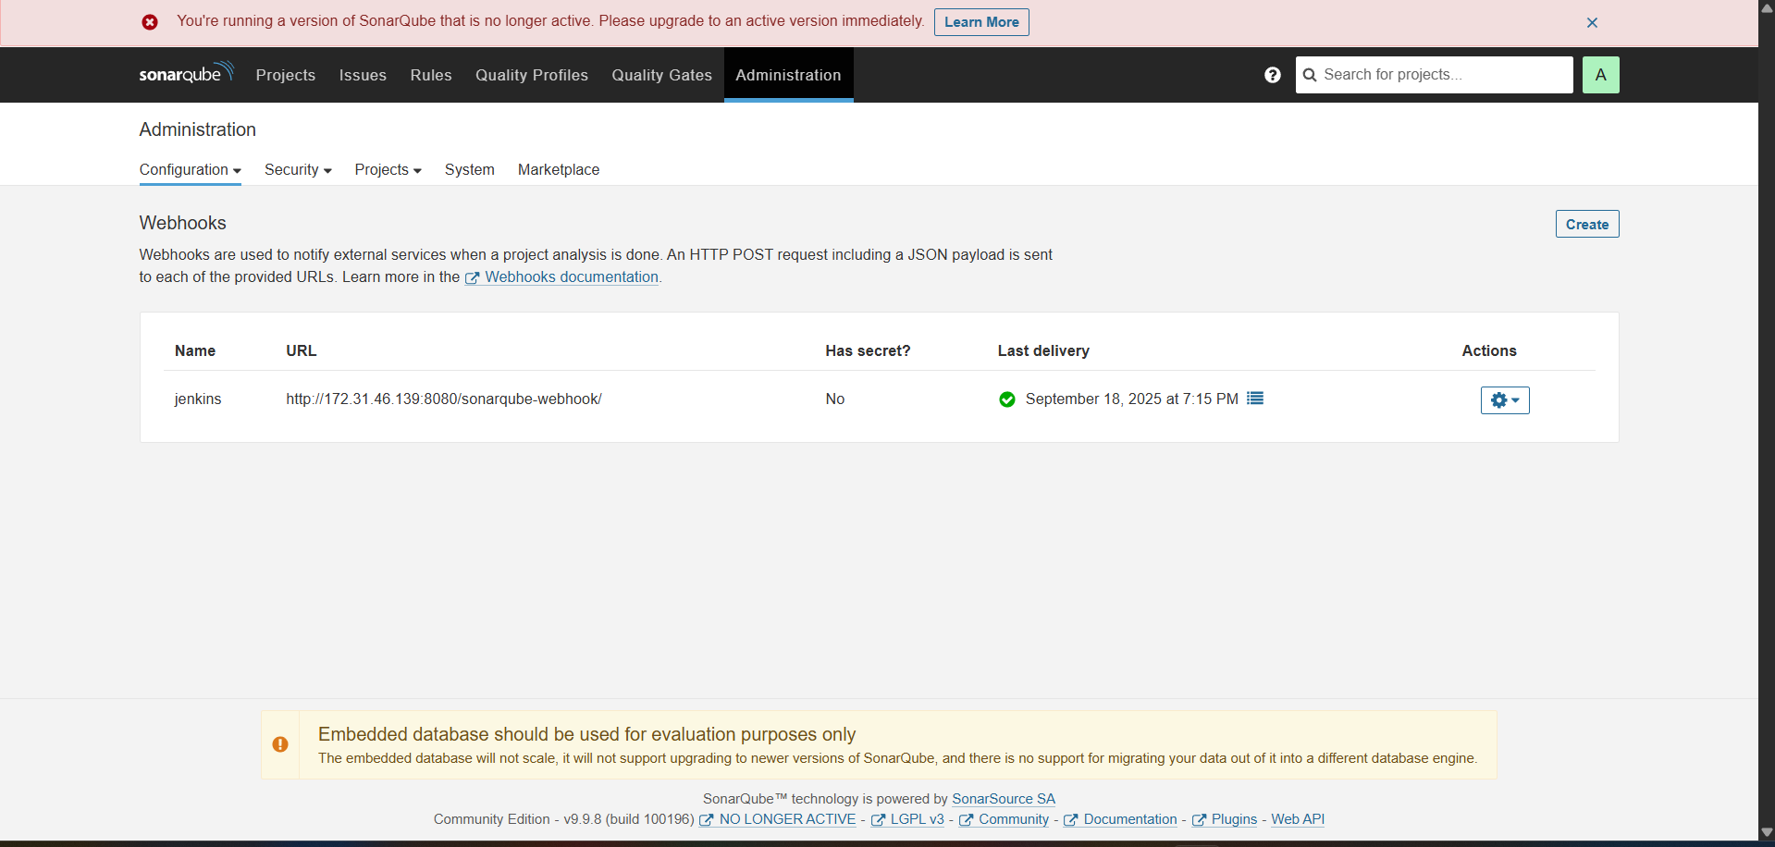

# premetheus dashboard

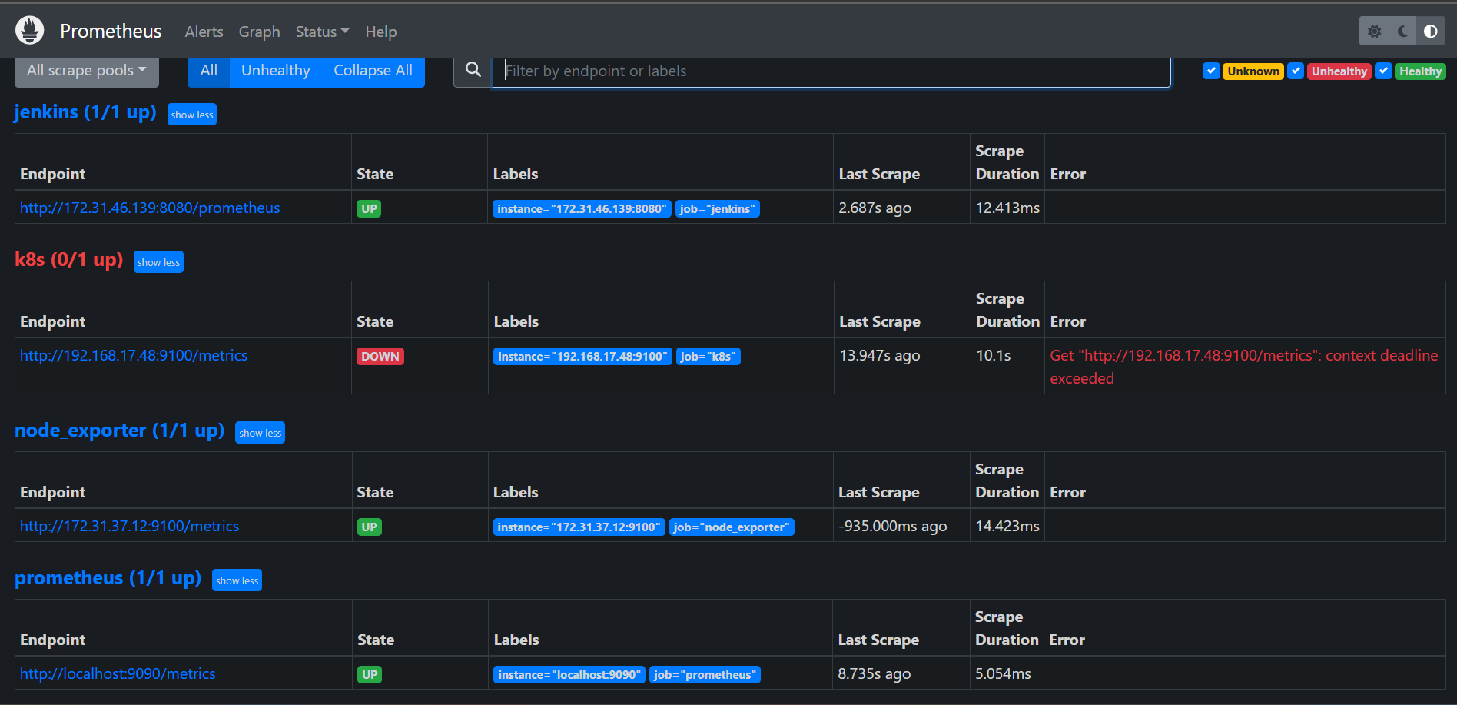

# Grafana dashboard Jenkins and node   
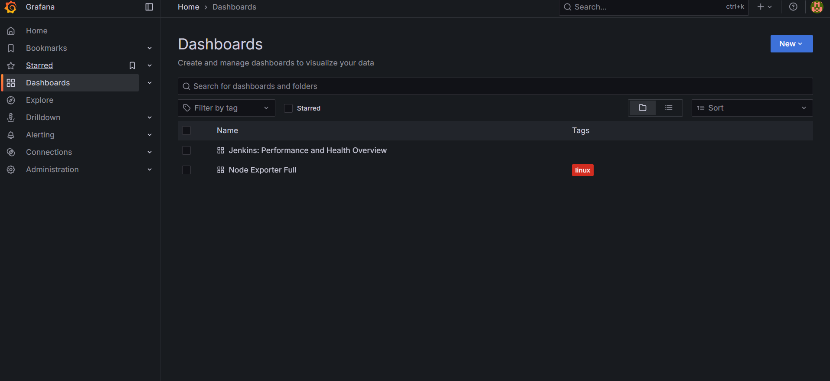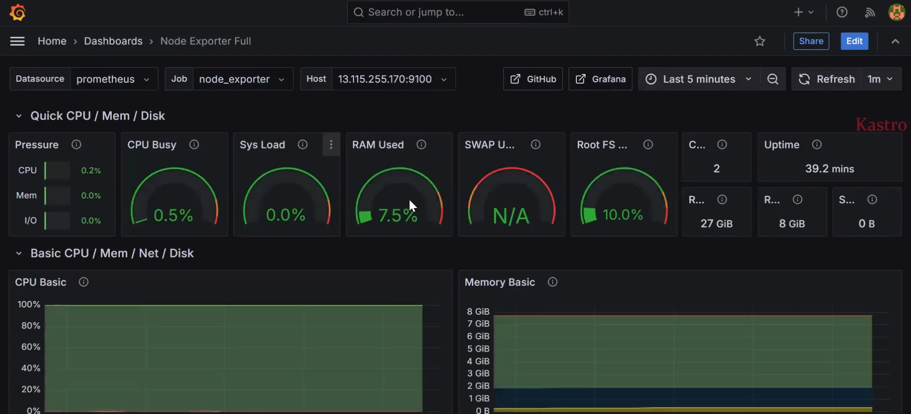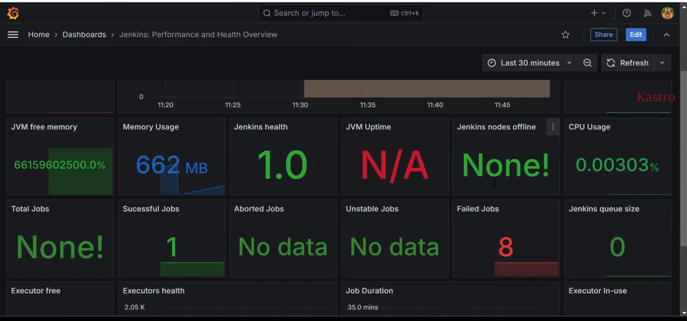

# clusters in aws

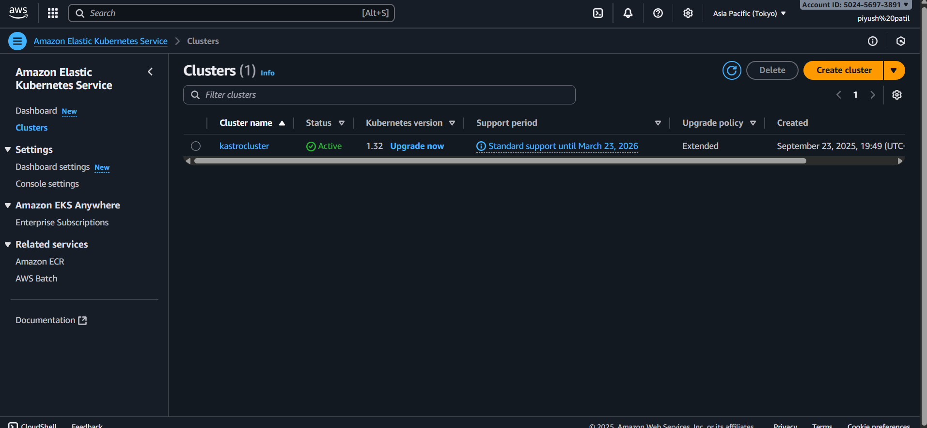

# k8s user in IAM

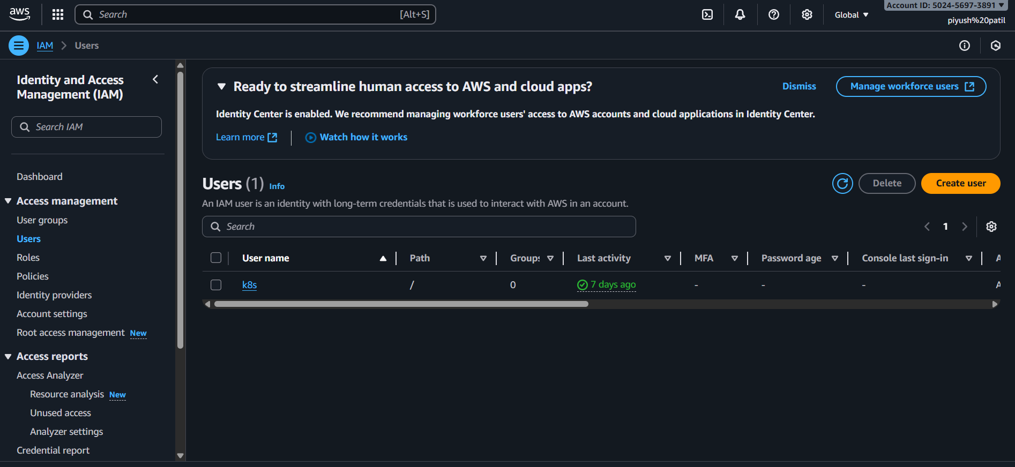

# Agro CD   
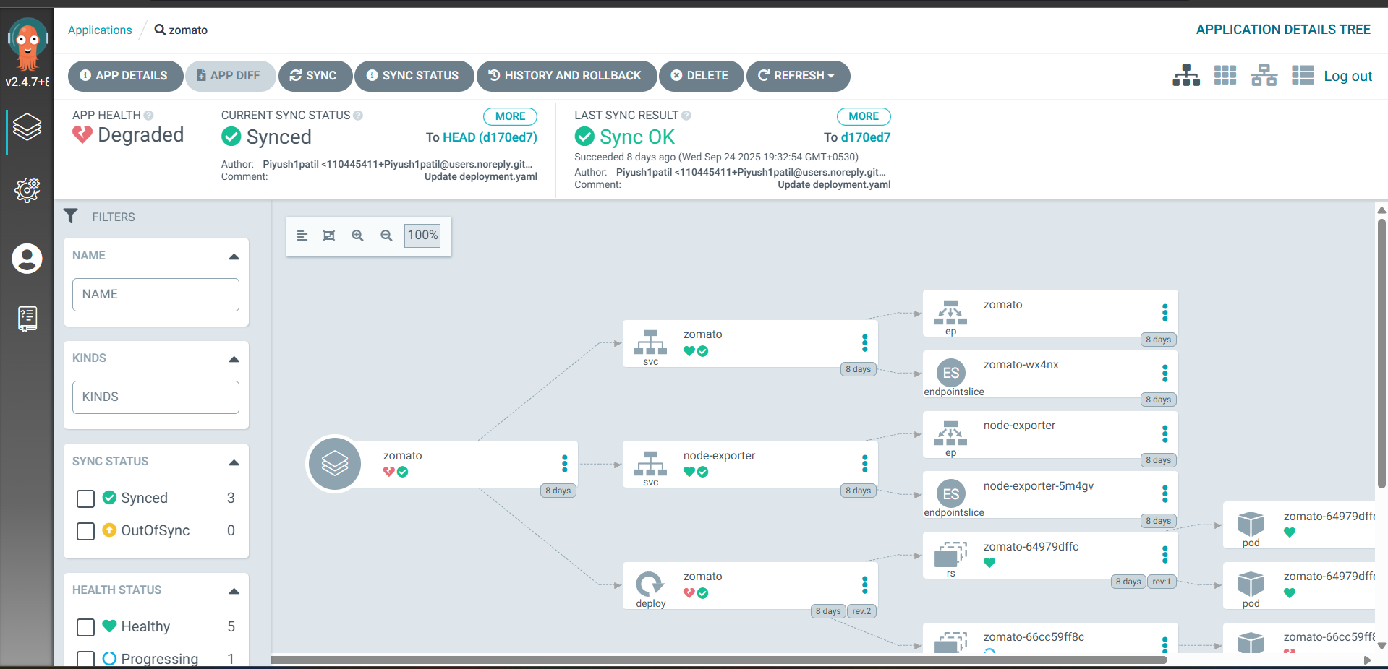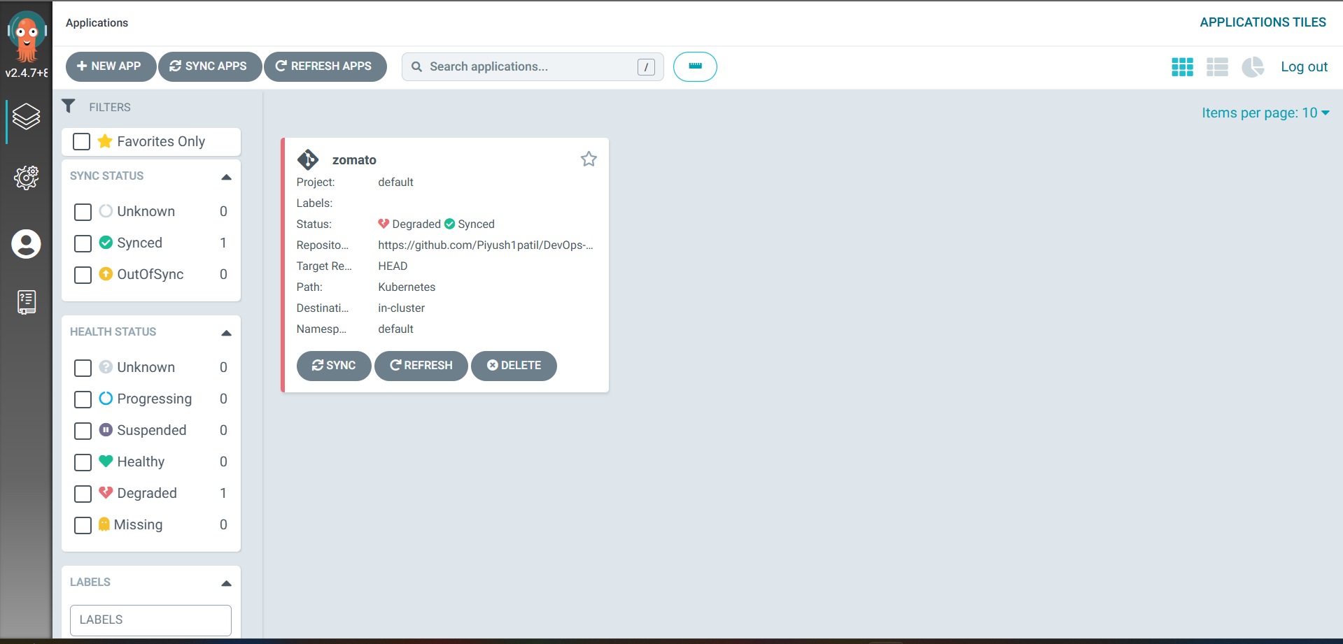

# zomato clone website hosted on Kubernetes clusters 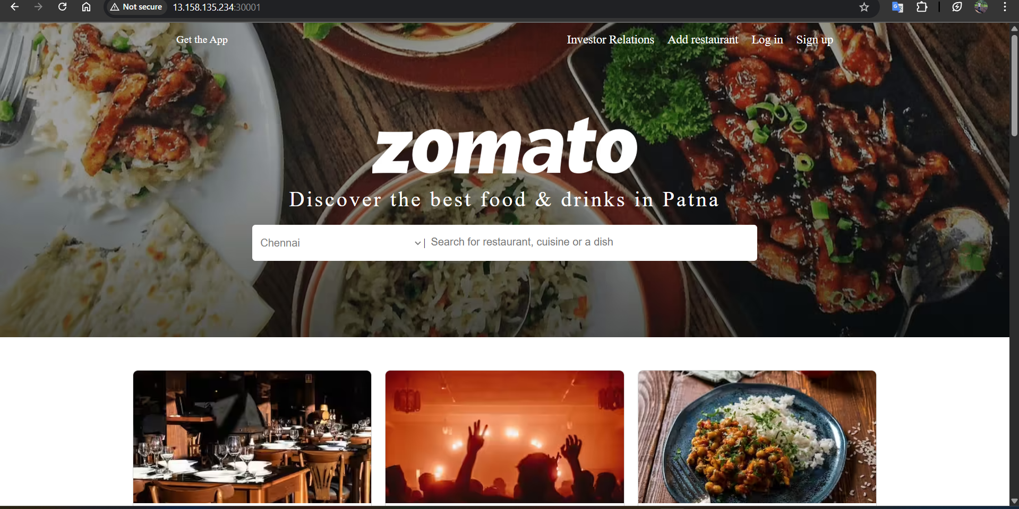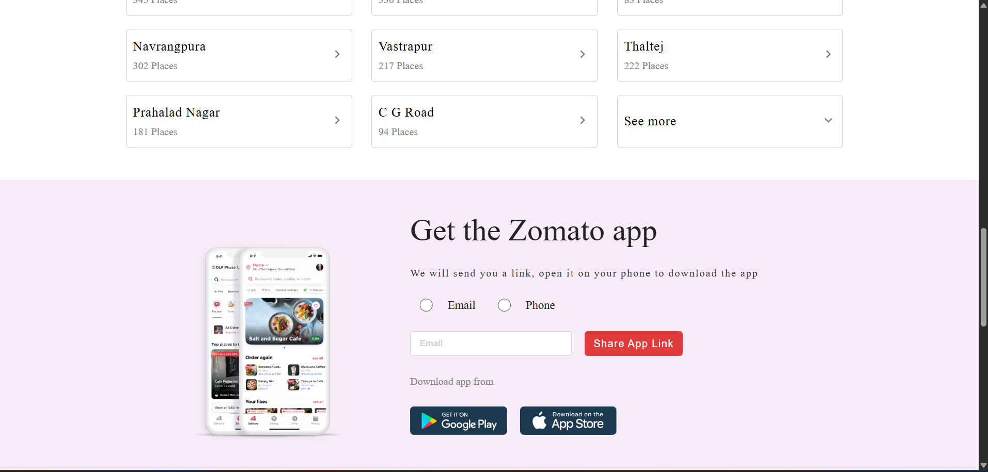

# use local poweshell to connect with aws and kubernates cluster

